# Getting Started and Setup with Oracle

This course uses the Oracle DBMS for the duration of the course. There are two ways that we access the database and they are:

* SQL Developer GUI

Each is described briefly with information provided on how to connect to the database space that has been assigned to you.

## SQL Developer GUI

1. Open the SQL Developer Application. There should be an icon on your desktop or in the start menu search for SQL Developer.
2. This screen will appear. If you previously logged on and made connections, there will be entries below the word connections. You can then click on those entries and it will save entering data each time.  
   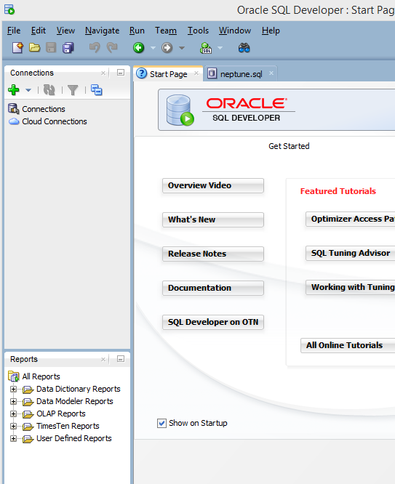
3. Click on the green PLUS to create a new connection and fill in the data as shown below. The connection name can be anything such as your id or initials.
   1. **Connection Name**: Anything: example: MyConnection or Your Initials
   2. **UserName and Password**: have been assigned to you
   3. **Save Password**: is optional, I would save it for class purposes, but in the real world, we would not save that information
   4. **Hostname**: myoracle12c.senecacollege.ca
   5. **Port**: 1521
   6. Click the **Service Name** radio button and enter: oracle12c
   7. **Test** the connect, if successful, click **Save** and then **Connect**

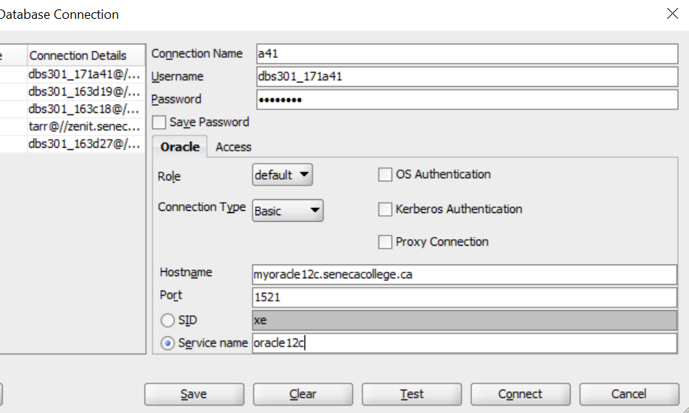

1. Once you successfully connect, the following screen appears:  
   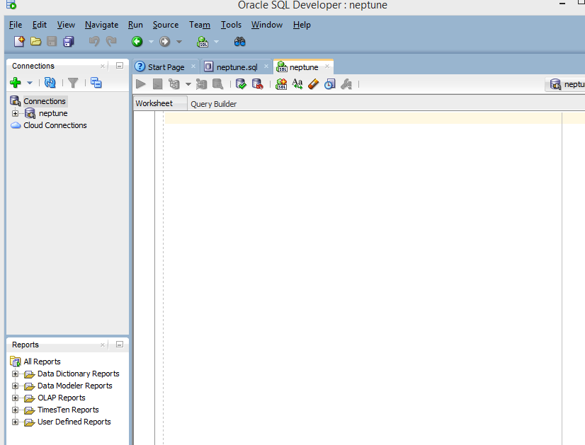
2. If you have not already done so in a previous session, you will need to run an SQL Creation script to create the tables, data, constraints, etc. for the database. Open the provided file in your favourite text editor (example: Notepad++), copy all of the content, and paste it into the large editor window shown above.  
     
   Run the script using the Run Statement button (ctrl-enter): It looks like a green arrow near the top left corner.  
     
   *NOTE: You may have to highlight all the lines with ctrl-A before clicking the run button.*
3. Expand the “Tables” section from the left menu. If the tables do not appear, try clicking the refresh button and the expanding tables again.
4. Erase the creation script from the SQL Worksheet window (ctrl-A and delete key).
5. Enter a simple SQL Select statement to test the data is present:  
   EXAMPLE:

SELECT * FROM employees;

1. If the data appears in the Query Results window at the bottom, you have successfully connected.

## SQL*Plus Command Prompt Window

The SQL*Plus command prompt window is exactly that: a command prompt window that allows you to connect to a database and run SQL commands directly from a prompt.

### Connecting to your database with sqlplus

There are two ways to connect, these depend on your computer configuration and environmental variables setup.

The first way is through the general command prompt

1. Open a normal windows command prompt: start/run and type CMD or in Windows 10 start and just type CMD
2. At the command prompt type in the following information:

C:\sqlplus username/password@server_address/service_name

Example 2:

C:\sqlplus [dbs301_172a01/12345678@myoracle12c.senecacollege.ca/oracle12c](mailto:dbs301_172a01/12345678@myoracle12c.senecacollege.ca/oracle12c)

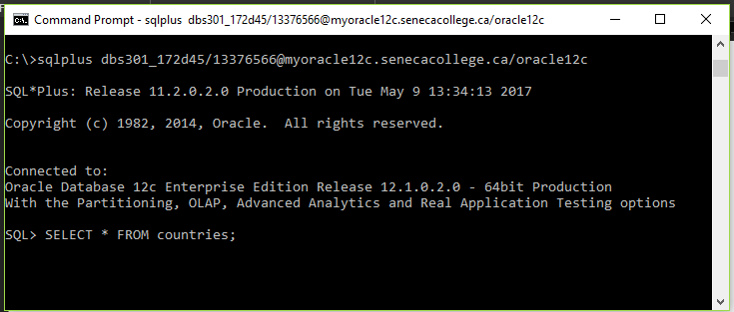

1. Once the connect is successful, you will be given a SQL> prompt to type commands in from there.
2. Try typing in the same SELECT statement as above to test if it works! HINT: don’t forget the semi-colon.
3. When you are done, you can exit sqlplus by typing “EXIT” at the SQL prompt.

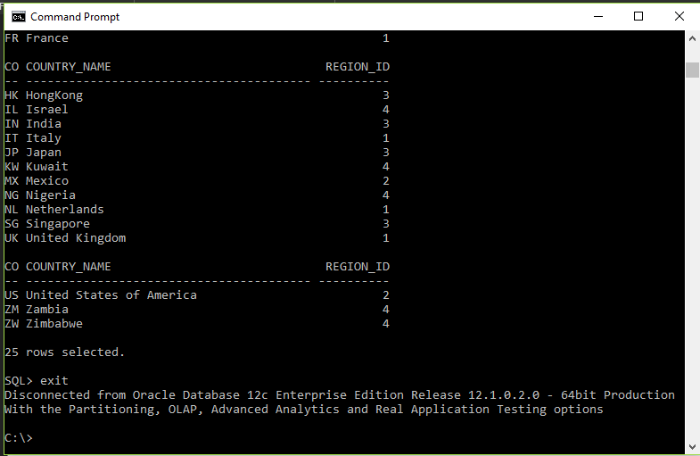

The second way to connect to SQLPLUS is to run the SQL Command Line

This can be found in your start menu as well.

1. Windows 10: Click start and type SQL Command OR SQLPLUS and it will appear.  
   Windows 7: SQL Command Line or SQL PLUS should be found in your programs folder in the start menu
2. At the SQL Prompt enter “connect” followed by the connection string (same as above)  
   see screenshot for example:

